Stage Illustration
The backdrop of the stage includes a banquet of Ballerina flowers, which will be carried by Hannah as she enters the stage with the others. another prop that is part of the backdrop include the sketchpad that Ashley draws on. The stage is flanked by curtains in three of its dimensions while the fourth dimensions faces the audience.
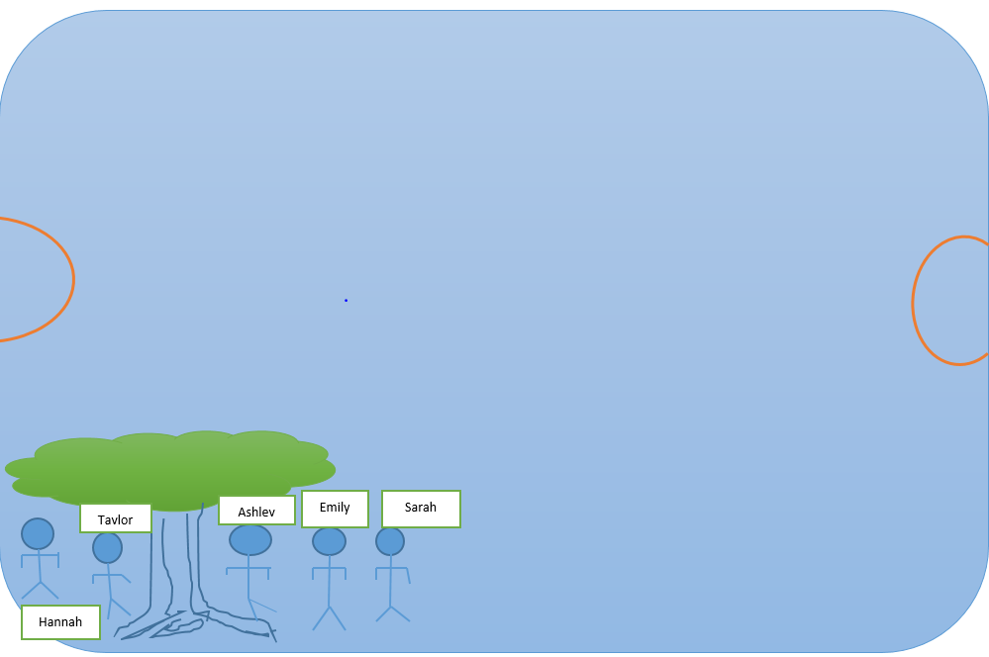
The set of the play onto a stage would be as seen in the above illustration. It is a simplistic depiction of the major props in the play. The main characters depicted in the play include Ashley, Taylor, Emily, Sarah, and Hannah. At first Ashley is alone beneath a tree in a corner of the playground, but she is joined by Taylor after a while. As they continue to talk about the death of Ashley’s mum, they are joined by Emily, Sarah, and Hannah. The important props in this play include a playground and a big tree under which Ashley sits. The stage is set to illustrate what a typical would look a like; four corners, two goal posts, and the central area. In the context of this play, all the actors would be placed at one of the corners. They would emerge at an area around the goal post near that corner and stand around Ashley.
The stage illustration is backed by the narrations in the play that indicate what it should be look. It has to appear like an open field with a tree placed at one corner. It is important that the illustratable props be shown such as the relative position of each of the actors while other props such as the sketchpad that Ashley is holding and the ballerina flower may not be seen in the stage illustration. The props that are crucial are those used to set the mood of the play as well as its premeditated atmosphere. In this case, the actor has to appear similar and of the same size owing to the fact that they are in school. Despite being in school, the specific area is the playground and not in class.

